**St Mary’s University**



**Faculty of Informatics**

**Department of Computer Science**

**SENIOR PROJECT PROPOSAL**

|  |  |  |  |
| --- | --- | --- | --- |
| **Group Members** | | | |
|  | **Name** | **ID No.** | **SECTION** |
| **1** | Dawit Teka | RCD/0168/2014 | A |
| **2** | Temesgen Berhane | RCD/0148/2014 | A |
| **3** | Wubtsega Sitotaw | RCD/0160/2014 | A |
| **4** | Yididya Bililign | RCD/0150/2014 | A |

**Date: Oct 21/ 2024**

# Topic 1: Web-Based Purchase Order Management System

## Type:- Website Application

## 1. Introduction:

The advancement of technology has revolutionized the way organizations handle their internal processes. One critical area is the management of purchase orders. Many organizations still rely on traditional methods such as paper-based or email-based ordering, which can lead to inefficiencies, delays, and errors. A web-based purchase ordering system offers a streamlined solution, providing businesses with a digital platform to create, manage, and track purchase orders in real time.

This project proposes the development of a web-based purchase ordering system that automates the procurement process, providing a user-friendly interface for submitting, approving, and tracking purchase orders. The system will reduce errors, improve process efficiency, and offer data analytics for better decision-making.

## 2. Statement of the Problem:

During our recent industry internship program we all, in our respective company, witnessed a trend where material acquisition takes the most time, impeding the progress of a project to a great degree. Upon deeper observation we learned that the cause for it all lies in the old and outdated traditional purchase ordering process companies use to purchase the products.

Traditional purchase ordering systems, whether paper-based or managed through emails, often lead to various challenges such as:-

* Manual entry errors
* Delayed approvals
* Lack of transparency in supplier selection
* Inefficient reporting and auditing
* Difficulty in managing multiple orders at once

These issues can cause delays in procurement processes, resulting in lost opportunities, increased costs, and overall inefficiencies. Organizations require a digital solution that simplifies the ordering process, automates workflows, and enhances transparency across departments.

## 3. Objectives:

The primary goal of this project is to develop a web-based system that automates the purchase ordering process. The specific objectives include:-

* **Automation**: Design a system that automates the process of creating, submitting, and approving purchase orders.
* **Tracking**: Implement real-time tracking of request status to enhance transparency.
* **Error Reduction**: Minimize manual errors through automated calculations and data validation.
* **User-Friendly Interface**: Create a system that is easy to use for all stakeholders, from employees to managers and administrators.
* **Reporting**: Develop a robust reporting system that provides insights into procurement trends, expenses, and bottlenecks.
* **Security**: Ensure the system is secure with role-based access control and audit trails for compliance purposes.

## 4. Scope:

The scope of this project covers the following aspects:-

* **User Roles**: The system will support various user roles, such as *Employees\** (who create purchase orders), *Managers\** (who approve/reject orders), *Vendors\** (who compete by submitting proforma invoice), and *Administrators\** (who manage the overall process).

*\* - Actors on the system*

* **Core Features**: The key features include purchase requisition, proforma application, purchase order creation, approval workflows, order tracking, payment method, and reporting.
* **Platform**: The system will be developed as a web-based platform accessible via modern web browsers.
* **Security**: The project will ensure that user data and order information are secured using authentication and role-based access control.
* **Reporting**: The system will provide analytics and reporting on purchase order activities.

## 5. Significance of the Project

The implementation of a web-based purchase ordering system is expected to have several benefits:-

* **Efficiency**: The automation of purchase orders will reduce time spent on administrative process and bureaucracy, leading to faster procurement cycles.
* **Error Reduction**: Automated data entry and validation will reduce the likelihood of human errors, enhancing the accuracy of orders.
* **Transparency and Accountability**: Real-time tracking and audit trails will make the process transparent, allowing organizations to better monitor and manage their procurement activities.
* **Cost Savings**: By streamlining processes and reducing errors, organizations will be able to save time and money.
* **Better Decision-Making**: The built-in reporting and analytics features will provide actionable insights into procurement trends and spending, helping managers make informed decisions.

## 6. Methodology

The project will follow the Agile development methodology, which allows for iterative design and development. The key phases will include:-

* **Requirements Gathering**: Meeting with stakeholders to define the specific needs and features of the system.
* **System Design**: Creating wireframes and design prototypes, focusing on usability and ease of navigation.
* **Development**: Coding the system in iterations (sprints), incorporating features incrementally.
* **Testing**: Conducting unit, integration, and usability testing (user acceptance testing/UAT) to ensure that the system is functioning as expected.
* **Deployment**: Hosting the system on a cloud platform and making it accessible to users.
* **Maintenance and Feedback**: Post-deployment, gathering feedback for continuous improvements and ensuring regular maintenance for bug fixes and updates.

## 7. Technology Tools

To achieve the project objectives, the following tools and technologies will be used:-

* **Front-end**: HTML, CSS, JavaScript (React.js or Angular.js for a responsive user interface)
* **Back-end**: Node.js or Python (Django or Flask) for handling server-side operations
* **Database**: MySQL for managing purchase order data
* **Version Control**: Git and GitHub for source code management
* **Payment Integration**: Payment gateway APIs to complete the purchase process

## Required Background:

* **Web development**: Certain level of proficiency in the use of scripting and programming languages such as HTML, CSS, and JavaScript For adding interactivity and functionality to the UI. Familiarity with frameworks like *React.js*, *Angular.js*, or *Vue.js* can greatly enhance the user experience. Also knowledge in back-end Development, Server-side Programming, experience with Node.js, APIs, and Web Services.
* **Database Management**: Experience with databases like MySQL or SQLite to manage data. Knowledge of Entity-Relation (ER) diagrams, designing schemas, and structuring data efficiently for managing orders, users, approval workflows, and more. Proficiency in SQL for querying the database, managing transactions, and maintaining data integrity.
* **Domain Knowledge**: Regarding the process in which companies purchase goods, the involved personnel, their tasks and responsibilities, and range of activities.
* **UI/UX Principles**: Understanding of how to design intuitive and easy-to-navigate interfaces that align with the end-user’s needs. Experience with design tools like Figma, Adobe XD, or Sketch for creating wireframes and mockups before development.

## Required Resource:

For ease in development, laptops with:

* **Hardware**: Development and testing machines with appropriate specifications. At least 6GB Ram, 50GB storage stapce (Necessary to install all required frameworks), more than 2.5 GHz processing speed.
* **Software**: Integrated Development Environments (IDEs) like Visual Studio Code, database management tools like MySQL, and project management tools for agile development.

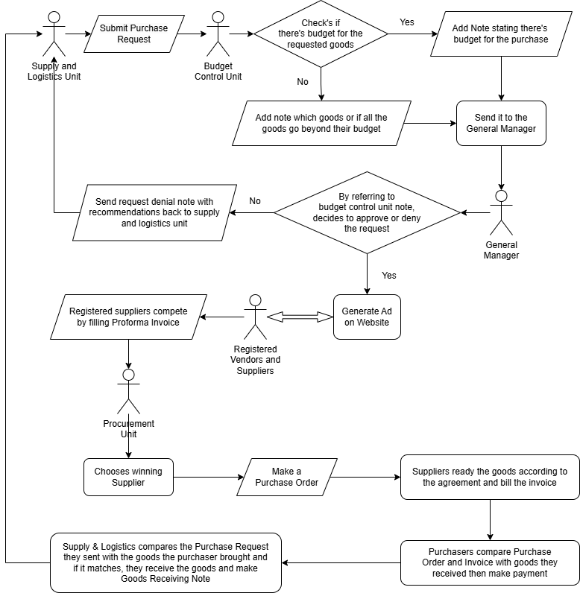

# Topic 2: Desktop-Based construction Management System

## Type:- Desktop Application

## Introduction

The construction industry is a dynamic and complex sector that requires efficient management of resources, time, and workforce. Construction projects involve numerous activities such as project planning, scheduling, cost estimation, inventory management, and document handling, which are often handled manually or through disparate software. A well-integrated desktop-based application for construction management can streamline these tasks, reduce errors, and increase overall productivity. This proposal outlines the development of such a system to enhance the management process in construction projects.

## 2. Statement of the Problem

Many construction companies still rely on outdated methods or fragmented software solutions for managing construction projects. These traditional systems lead to inefficiencies, such as poor project tracking, lack of real-time data sharing, cost overruns, missed deadlines, and difficulty in managing multiple projects. A comprehensive, user-friendly desktop application is needed to centralize and automate construction management processes, reducing human error and improving decision-making.

## 3. Objectives

The primary objective of the project is to develop a desktop-based construction management application that will:

* Provide a centralized platform to manage construction projects from start to finish.
* Automate project scheduling, resource allocation, and cost estimation.
* Track progress and generate real-time reports on project milestones.
* Manage inventory and procurement processes efficiently.
* Ensure effective communication and document handling among stakeholders.

## 4. Scope

The proposed system will be designed for small to medium-sized construction companies. It will:

* Support project management functionalities such as scheduling, task assignment, and resource allocation.
* Include modules for budgeting, cost tracking, and financial reporting.
* Provide inventory and procurement management features
* Offer document management, allowing for the storage and sharing of important files.
* Be developed as a desktop-based application, which can later be extended for cloud integration if necessary.

## 5. Significance of the Project

The proposed application will have a significant impact on construction management by:

* Reducing operational inefficiencies and project delays.
* Improving resource allocation and minimizing material wastage.
* Enhancing collaboration between project managers, contractors, and stakeholders.
* Enabling better financial planning and cost control.

## 6. Methodology

The project will follow an agile development methodology, which allows for iterative development and continuous feedback from users. The key phases are:

* Requirement gathering: Understanding the specific needs of construction managers through surveys and interviews.
* System design: Creating architectural diagrams and user interface designs for the application.
* Development: Implementing the core features of the application in iterative sprints.
* Testing: Conducting unit, integration, and user acceptance testing to ensure the application meets its objectives.

## 7. Technology Tools

* Programming Language: C#, Java, or Python for the core application development.
* Database: SQLite or MySQL for managing project data.
* User Interface: Windows Presentation Foundation (WPF) or JavaFX for the desktop interface.
* Version Control: Git for managing the codebase.
* Testing Framework: NUnit or JUnit for testing the application.

## Required Background:

* Proficiency in desktop application development using C#, Java, or Python.
* Experience with relational database management systems (SQLite, MySQL).
* Knowledge of construction management processes and workflows.
* Expertise in user interface design for desktop applications.

## Required Resource:

For ease in development,

* Hardware: Development and testing machines with appropriate specifications. At least 8GB Ram, 50GB storage stapce, more than 3.0 GHz processing speed.
* Software: Integrated Development Environments (IDEs) like Visual Studio or IntelliJ IDEA, database management tools like Microsoft SQL, and project management tools for agile development.

# Title 3: Employee Tracking System for Efficient Workforce Management

## Type:- Web App Development

## 1. Introduction:

Employee productivity and attendance management are critical factors in any organization’s success. However, manual systems of tracking employee work hours, attendance, task completion, and overall productivity can be prone to error, time-consuming, and inefficient. The proposed Employee Tracking System (ETS) seeks to automate these processes using a web-based solution that allows seamless tracking of employee activities and task completion in real-time. With this system, management will be better equipped to oversee employee activities, increase productivity, and maintain transparency across the organization.

## 2. Statement of the Proposal:

The Employee Tracking System is designed to enhance managerial control over employee time management, task assignments, and productivity. This system will serve both management and employees. The main features of the system include a dashboard for real-time attendance tracking, task management tools for monitoring progress, automated alerts for abnormal behaviors (such as consistent late arrivals), and leave management. The system will be easily accessible on both desktop and mobile platforms, ensuring high accessibility for all users.

## 3. Objectives:

The primary goals of the Employee Tracking System are:

* **Real-time Attendance Tracking**: Allow managers to monitor when employees clock in and out, reducing the possibility of time fraud and attendance issues.
* **Task Management and Tracking**: Assign tasks, set deadlines, and monitor the progress of assigned work for individual employees.
* **Productivity Monitoring**: Track the time employees spend on various tasks, helping to identify patterns in productivity.
* **Automated Notifications**: Send alerts to employees and managers in case of irregularities, such as late check-ins, missed deadlines, or overtime work.
* **Leave and Schedule Management:** Provide employees with an interface to request leave, track holidays, and access their work schedules, which management can approve or adjust accordingly.
* **Data Security and Privacy:** Ensure that all employee data, including personal and attendance-related information, is securely stored, accessed only by authorized personnel, and protected from breaches.
* **Reporting and Analytics**: Generate insightful reports on employee performance, attendance trends, task completion rates, and productivity, helping management make data-driven decisions.

## 4. Scope of the Project:

The Employee Tracking System will be developed as a web application accessible via desktop and mobile devices. The system will be divided into two main portals:

* **Employee Portal**: Allows employees to view their attendance records, task assignments, and progress, request leaves, and update their personal details.
* **Manager Portal:** Offers comprehensive tracking of employee attendance, task completion, leave management, and productivity. It also provides features for generating reports and setting up automated alerts for critical behaviors such as overtime and underperformance.

The system is designed for small to medium-sized enterprises but can be scaled for larger organizations. The key functionalities are as follows:

* **Time and Attendance Tracking**: Employees can log in and out using unique credentials, and the system will record their exact check-in and check-out times.
* **Task Assignment and Monitoring:** Managers can assign tasks to employees, track progress, and assess completion times.
* **Employee Performance Insights:** The system will generate reports for each employee's performance based on metrics such as attendance, task completion rate, and overall productivity.

## 5. Significance of the Project:

Implementing the Employee Tracking System will significantly enhance the company's ability to manage its workforce efficiently. The system will:

* **Reduce Time Management Issues**: By automating attendance tracking and task management, the company will cut down on time lost due to manual monitoring, leading to increased productivity.
* **Enhance Managerial Control:** Managers can stay informed about employee activity in real-time, allowing them to make informed decisions and address issues such as absenteeism or underperformance more effectively.
* **Improve Transparency and Accountability:** Employees will be aware that their performance and attendance are being tracked in real-time, fostering a sense of accountability and encouraging better time management.
* **Boost Productivity:** With task assignments and tracking, employees are encouraged to complete tasks within deadlines, and managers can allocate resources more efficiently based on performance insights.
* **Better Data Security and Privacy:** The system will ensure all employee data is protected, following best practices in data encryption and access control.

## 6. Methodology and Technology Tools:

This project will follow the Agile Methodology, ensuring that the system is developed iteratively with regular feedback from stakeholders. The development will be divided into sprints, and each sprint will focus on building and testing a specific module of the system. Regular testing and updates will ensure a smooth, bug-free product delivery.

* **Technology Stack:**
* **Backend Development:**
* Spring Boot Framework (Java) will be used for the backend, ensuring a robust and scalable system capable of handling large amounts of data and requests efficiently.
* RESTful APIs will be implemented to facilitate seamless communication between the backend and frontend.
* **Frontend Development:**
* React.js will be used for the frontend development, providing a highly responsive user interface for both employees and managers.
* HTML5, CSS3, and JavaScript will be utilized to create an interactive and user-friendly web interface.
* **Database:**
* MySQL will be used for the database, ensuring that employee data, such as attendance records, task lists, and personal information, is stored securely.
* **Tools and Libraries:**
* JSON for efficient data interchange between client and server.
* Git for version control, ensuring the codebase is secure and tracked across all stages of development.
* **Required Background:**
* Java (Spring Boot)
* Web Development (HTML/CSS/JavaScript)
* JSON (Data Handling)
* MySQL/PostgreSQL (Database Management)
* Data Security and Encryption Tools
* **Required Resources (Hardware and Software)**
* **Hardware:**
* Servers for hosting the web application and database.
* Laptops or desktops for development and testing.
* **Software:**
* Spring Boot Framework for backend development.
* React.js for frontend development.
* MySQL for database management.
* Git for version control and collaboration.
* Eclipse or IntelliJ IDEA for integrated development environments (IDE).
* Postman or Insomnia for API testing.

**Requested Advisor List**

**Haileyesus Tilahun**

**Dagmawi Yewlsew**

**Dawit Yetmgeta**